This script is used to export images from layers downloaded as a geodatabase from ArcGIS Online. Please be sure you have done this prior to running this tool.

Creating a tool based on the Export Attachments Script

1. Open your ArcGIS Pro Project.
2. Ensure you are in the Catalog Pane and open the Toolboxes folder
3. Right click on your Toolbox and create a new script.
   1. 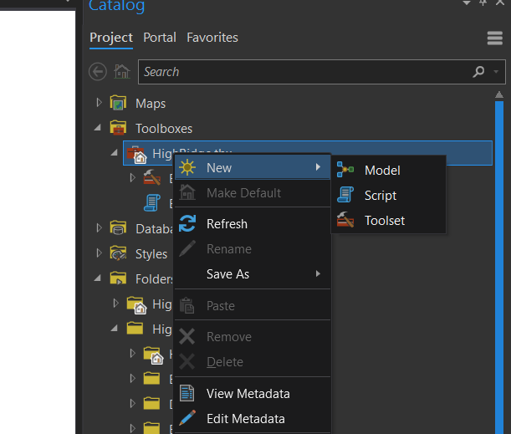
4. In the New Script window, name your script and prescribe a label. For Script File navigate to the location where you saved the export attachments script.
   1. 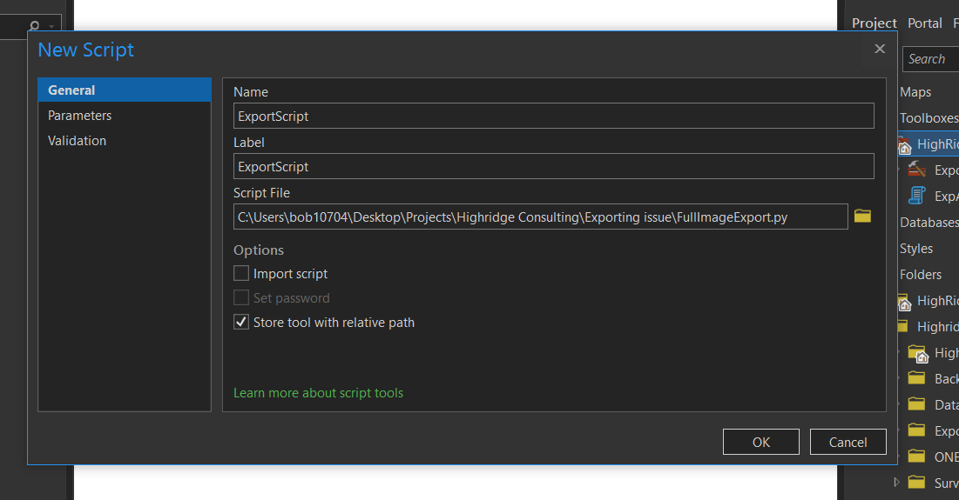
5. Select the Parameters tab and fill in as below.
   1. 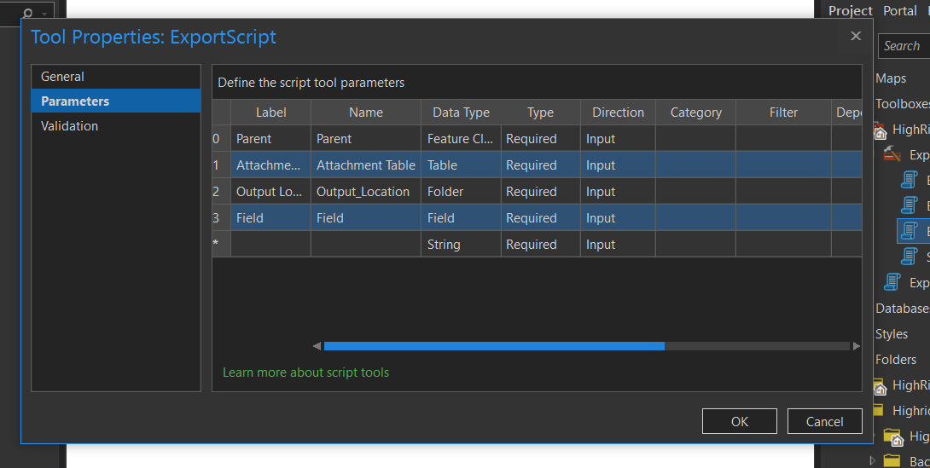
   2. The Parent parameter is the feature class you will be pulling the Route ID (or pertinent field) from. For instance, if you are downloading attachments for Atmospheric Inspection you will select the downloaded Atmospheric Inspection point layer.
   3. Attachment Table is the table that houses the images downloaded from AGOL. It will be labeled as {Layer}_Attach.
   4. Output Location represents the intended location of output.
   5. Field represents the field from the Parent layer that you wish to pass into the naming convention.
      1. Scroll to the right until you reach the “Dependency” column. Set this to Parent. This allows you to choose the appropriate fields to import into the image name.
6. Select OK. Your tool has now been created and can be accessed from the Catalog pane in Toolbox.
   1. 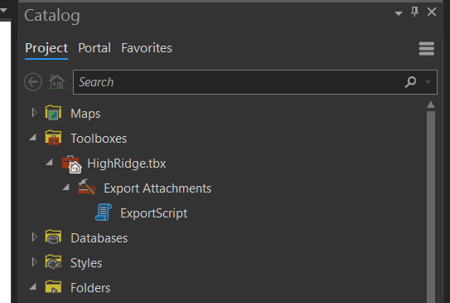

Using the Image Export Tool

1. From the Catalog Pane, either double click on the script or right click and select Open.
2. Now you will select the parameters that determine what images to download as well as the naming convention.
   1. 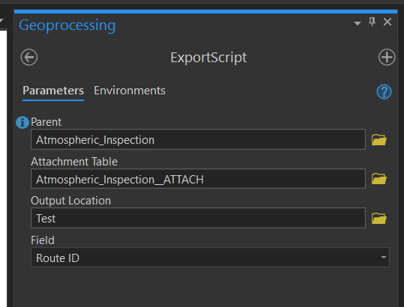
   2. For parent, select the pipeline file downloaded with your selection from ArcGIS Online. Do this by clicking the folder and navigating to where you saved the desired geodatabase.
   3. Attachment Table will be the table associated with the element you select. For instance, if we are downloading the images for Atmospheric Inspection, the table you select will be labeled Atmospheric_Inspection_ATTACH with a table symbol before it. 
   4. Output location will be the desired location you wish to save the images.
   5. The “Field” parameter is the field from the parent layer you wish to pass into the name of the downloaded images. In the case of NGL and NGGP, we would select Route ID.
   6. Click Run.
3. Navigate to your desired output location and verify the files have downloaded. For the sample listed above, the output file names would be as follows: Route14783_NGGP_Atmospheric_Image_4-20200712-154551